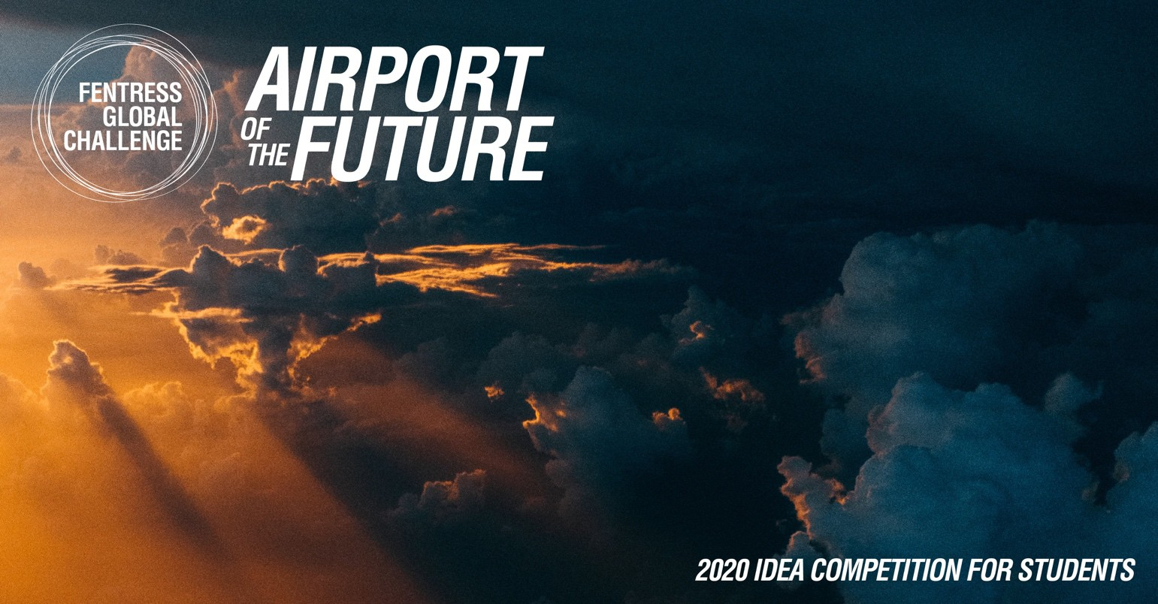

# ABOUT THE COMPETITION

Despite a multitude of technological advances including video conferencing and drones, the proliferation of airports worldwide continues to be spurred on by global commerce and an unrelenting demand for travel.

While the airport terminal—conceived a century ago—is a relatively new architectural typology, it has since its inception held equal importance with quintessential civic buildings: city halls, courthouses, libraries, museums, and theaters. Yet, airports are uniquely complex and they are more than just high volume transportation hubs. Increasingly, airports are also workplaces, centers of commerce, recreational outlets, and cultural resources.

Fentress Global Challenge (FGC) is an annual international student design competition. Since its inception in 2011, thousands of entries from over 75 countries have competed for top honors. FGC represents an extraordinary exploration into the future of architecture, and in so doing, continues to advance the pursuit of innovative design in public architecture.

# ELIGIBILITY

FGC is open to graduate and undergraduate students currently pursuing architecture or engineering degrees in an accredited university program, as well as recent graduates (within the last four years) with a degree in architecture or engineering. Current students must provide proof of active enrollment status: a scanned copy of their student ID and current course schedule. Recent graduates must provide a scanned copy of their diploma.

# GUIDELINES

FGC participants are challenged to envision a terminal building for the year 2100. Concepts must:

1. **Create a new airport terminal concept.** Entrants are encouraged to utilize forecasts for population, environmental conditions, modes of travel, and potential destinations in the creation of their concept.
2. **Employ Fentress’ Touchstone 2: Use Context to Create Identity. “**Context is more than an intellectual consideration of the history or physical appearance of a neighborhood, city, or state, and it’s more than the way new will live with old. Context draws on the senses, the sights, smells and memories that define a place and make it unique. Context grows from community, and people respond to it.” For more on Fentress’ Eight Touchstones of Design: https://fentressarchitects.com/design-philosophy.

## Improve upon at least one primary factor influencing airport terminal building design in 2100.

Entrants are encouraged to make projections about the factors that will most influence airport

architecture in the future. Examples of factors include mobility, urbanization, globalization, technology, flexibility, security, project feasibility, and passenger experience.

1. **Achieve sustainability and resiliency.** Sustainable design is the creation of places that are environmentally responsible, healthy, equitable, and profitable. Resilient designs are capable of adapting to changing conditions and maintain or regain functionality in the face of natural and manmade disasters.

## Site the new terminal at one of the 20 busiest airports (by passenger volume) in the world:

* + Hartsfield-Jackson Atlanta International Airport ATL
  + Beijing Capital International Airport PEK
  + Dubai International Airport DXB
  + Los Angeles International Airport LAX
  + Tokyo International (Haneda) Airport HND
  + O’Hare International Airport ORD
  + Heathrow Airport LHR
  + Hong Kong International Airport HKG
  + Pudong International Airport PVG
  + Aéroport de Paris-Charles de Gaulle CDG
  + Amsterdam Airport Schiphol AMS
  + Indira Gandhi International Airport DEL
  + Guangzhou Bai Yun International Airport CAN
  + Flughafen Frankfurt/Main FRA
  + Dallas/Ft Worth International Airport DFW
  + Incheon International Airport ICN
  + Atatürk International Airport IST
  + Soekarno-Hatta International Airport CGK
  + Singapore Changi Airport SIN
  + Denver International Airport DEN

# EVALUATION CRITERIA

Use clear, concise language to convey ideas, key points, and design solutions. Photographs, diagrams, renderings, animations, collages, and other visualizations are encouraged to help explain the concept, respecting the guidelines previously described. Please label drawings.

## APPROACH

The design approach is innovative and inspiring. Both the concept and design solution are presented through unique and compelling graphics and other media.

## RESPONSE TO SITE

The design honors the physical attributes of the site’s context and culture. The overall design strategy matches the global and local demographic requirements of the location. Again, use context to create identity.

## SUSTAINABILITY & RESILIENCY

The design minimizes negative impacts to the wellbeing of humans and the natural environment. The overall design strategy also responds to vulnerabilities including natural and manmade disasters.

## FUNCTIONALITY

The planning and building organization is clear and appropriate. The design solution contains a defined and well- articulated structural, technical, and constructible rationale.

# AWARDS

## 1ST PLACE – US$15,000

The top prize includes US$10,000 cash and the opportunity to accompany FGC Founder, Curtis Fentress, to a prestigious architectural event. Airfare, lodging, and entrance fee will be paid for by Fentress Architects (not to exceed US$5,000). Winners are responsible for obtaining necessary visas and paperwork. If entering as a group, the monetary prize and attendance at the architectural event will be distributed equally.

## 2ND PLACE – US$3,000

**3RD PLACE – US$2,000**

**PEOPLE’S CHOICE AWARDS (2) – US$1,000**

COMPETITION SCHEDULE

Competition Announcement: January 2020

Design Submission Deadline: July 31, 2020

Shortlist Announcement: September 4, 2020

Winners Announcement: October 2, 2020

# SUBMISSION REQUIREMENTS

Participants must register and upload competition materials to their profile page at [www.fentressglobalchallenge.com](http://www.fentressglobalchallenge.com/) no later than July 1, 2020 (23:00 GMT). Guidelines for the submission:

## Mandatory Formatting:

* Official language is English
* Official system of measurements is United States customary units
* File must be saved as a PDF and named as follows: “2020_(team name)_(design concept name).pdf”
* File must contain no more than eight (8) single-sided, 11-inch x 17-inch, landscape-oriented pages
* Each of the up to eight (8) pages must be labelled with page number and team name
* File size must not exceed 100MB

## Mandatory Content:

* Title of design concept
* Description of design concept (400-word maximum)
* Description of entrant (team or individual)
* Supporting images to include diagrams, plans, sections, and/or perspectives
* In a separate PDF, include photocopies of all student IDs (or other proof of school registration)

*Plagiarism and cheating will result in disqualification.*

# JURY

FGC will be judged in two stages. A first-round jury of distinguished experts will shortlist fifteen (15) designs from which a second-round jury will select the three finalists. Members of the jury—to be announced at a later date—will include airport directors, futurists, sustainability and resiliency experts, airport architects, and Fentress Fellows.

All shortlisted entries will also be eligible for the People’s Choice Award, which will be judged on Fentress Architects’ Facebook page. The two submissions receiving the most “likes” will win a prize of US$1,000 each.

# RULES AND REGULATIONS

By submitting an entry to Fentress Global Challenge, the participant accepts the following rules and regulations,

and all other terms related to the Fentress Global Challenge:

* No changes are permitted after an entry is submitted, unless approved by Fentress Architects.
* Participant agrees that, if requested by Fentress Architects, he or she will supply high resolution images for marketing, printing, or exhibition.
* All materials submitted for the competition must be the participant’s original work. It is the participant’s sole responsibility to ensure that the work submitted does not infringe upon the intellectual property rights of any third-party, including but not limited to copyright, trademark, and design rights. Fentress Architects shall not be responsible for participant’s infringement of any third-party intellectual property rights. Participant shall indemnify and hold harmless Fentress Architects against any claims related to third-party intellectual property rights regardless of whether said infringement was known, unknown, or should have been known by participant.
* Participant grants Fentress Architects and competition sponsors non-exclusive reproduction rights to all entries for Fentress Architects’ advertising, promotion, exhibition, print publication, and internet purposes directly relating to the competition. Fentress Architects shall have no responsibility for the unauthorized use of entrant’s works by any third party, including but not limited to the sponsors.
* All published and online media, including social media, related to the Fentress Global Challenge must be reviewed and approved by Fentress Architects.
* No prize transfer, assignment, or substitution by winners is permitted. If a prize (or part of a prize) is unavailable, Fentress Architects, in its discretion, reserves the right to substitute the original prize (or that part of the prize) with an alternative prize of equal monetary value and/or specification, unless to do so would be prohibited by law.
* Entrants agree personal data, especially name and address, may be processed, shared, and otherwise used for the purposes and within the context of the contest and any other purposes outlined in these official rules. The data may also be used by Fentress Architects in order to verify the participant’s identity, postal address, and telephone number or to otherwise verify the participant’s eligibility to participate in the contest. Participants have the right to access, review, rectify, or cancel any personal data held by Fentress Architects by writing to Fentress Architects, c/o Fentress Global Challenge, 421 Broadway, Denver CO 80203, USA. Fentress Architects will use personal data exclusively for the purposes stated herein.
* Fentress Architects reserves the right to verify the validity and originality of any entry and/or entrant (including an entrant’s identity and address) and to disqualify any entrant who submits an entry that is not in accordance with these official rules or who tampers with the entry process. Failure by Fentress Architects to enforce any of its rights at any stage does not constitute a waiver of those rights.
* Fentress Global Challenge rules and regulations are subject to change without notice.
* If for any reason the contest is not capable of running as planned, due to infection by computer virus, denial of service attacks, tampering, unauthorized intervention, fraud, technical failures, or any other causes beyond the control of Fentress Architects that corrupt or affect the administration, security, fairness, integrity, or proper conduct of this contest, Fentress Architects reserves the right, at its sole discretion, to disqualify any individual(s) who tamper with the entry process, and/or to cancel, terminate, modify, or suspend the contest. If Fentress Architects elects to cancel or terminate the contest, Fentress Architects will not retain any rights to the submitted designs.
* Any claims related to participation in the competition must be brought in Denver, Colorado, USA, and will be governed by the laws of the State of Colorado. This contest is void where prohibited.

# QUESTIONS & ANSWERS

Additional information available at: [www.fentressglobalchallenge.com.](http://www.fentressglobalchallenge.com/) Questions must be directed to: [info-fgc@fentressarchitects.com.](mailto:info-fgc@fentressarchitects.com)